THE TRANSITION TO COLLEGE FOR GENDER AND SEXUAL MINORITY YOUTH*

Alexandria Hurtt, Michal Kurlaender, Christina Sun, Kairo Weber, and Baiyu Zhou†
University of California, Davis

June 2024

Abstract

Purpose: Limited research considers the diversity within and across the binary dichotomy of gender identity and sexual orientation during the transition from high school to college. This study examines how college-bound students self-identify and explores patterns in high school experiences, college aspirations, and perceived concerns among gender minority (transgender, nonbinary, and gender diverse) students. Research Methods/Approach: We draw on the results of a large-scale survey administered to California high school seniors (n = 9,230). Employing a mixed methods approach, we utilize descriptive methods, regression and principal component analysis (PCA) to evaluate high school experiences and college concerns, and apply qualitative analysis to open-ended responses. Findings: Results indicate that students used a diverse set of labels to describe their identities and gender minority students plan to enroll in college at increased rates compared to their peers. We also find a statistically significant difference between the high school experiences of cisgender students and gender minority students, who report less positive experiences overall. Moreover, results from a PCA indicate concerns about college can be divided into three constructs: general worries, worries about discrimination, and worries about financial burdens. While gender minority students maintain higher levels of worry about discrimination overall, transgender students are more likely to report concerns about discrimination compared to nonbinary and gender diverse students. Implications: Our results emphasize the importance of identifying how experiences may differ across gender identities in order to develop and strengthen support systems for students navigating the transition from high school to college.

A college degree is increasingly important for today’s labor market and can offer a wide range of economic and social benefits (Chan 2016; Ma et al. 2019). However, the transition from high school to college—a significant milestone for many young adults—can be a challenge for students learning to dually navigate both new academic and social environments. As this transition is inherently shaped by the experiences one has while in high school (Lynn et al. 2010; Uwah et al. 2008), it is important to examine the experiences and aspirations of students at this time. Moreover, transitions in and of themselves are critical periods in a student’s educational trajectory, particularly for traditionally marginalized groups who may be more vulnerable (Perez and Farruggia 2021). While the literature on the transition to college has often drawn attention to the emergent differences across some subgroups (e.g., by race/ethnicity, income, first generation status), limited research considers the significant diversity within and across the binary dichotomy of gender identity and sexual orientation.
In fact, research indicates that gender and sexual minority students, including lesbian, gay, bisexual, transgender, and queer/questioning (LGBTQ+) youth, face significant discrimination during high school and may experience diminished postsecondary outcomes, including access to college (Sanlo 2004; Sansone 2019). Additionally, data on this population of students is sparse and recent studies tend to draw on a narrow sample of students (YouScience 2023), students in earlier grades (Austin et al. 2023; Kosciw et al. 2022; Reber and Smith 2023), or data collected pre-pandemic (Horowitz and Graf 2019; Sansone 2019; Wilkinson et al. 2021). Moreover, research in education often does not capture detailed information on gender identity and sexual orientation, inadvertently concealing the unique experiences of this population, particularly transgender and nonbinary students (Feldman et al. 2022; Glavinic 2010; Goldberg and Kuvalanka 2018). Therefore, it is critical to consider the differences that may emerge across gender identity and sexual orientation during the high school to college transition, particularly that of gender minority youth.
This work thus aims to extend the literature on the experiences of LGBTQ+ students during matriculation in several ways. Drawing on the results of a large-scale survey, we first examine how a broad population of California high school seniors describes their gender identity and sexual orientation given access to an extensive set of labels as well as the option to define their own. We then explore patterns in high school experiences and college aspirations among gender minority students and use a mixed methods approach to investigate the challenges faced by gender minority students as they consider the transition to college. Our results reveal a more expansive set of self-definitions for gender identity and sexual orientation and a rich description of the unique experiences, goals, hopes, and trepidations in the transition to college among gender diverse and LGBTQ+ youth.
This article is organized as follows: First, we broadly review scholarship on gender identity and sexual orientation and situate this analysis within a framework that considers the confluence of factors that can impact one’s educational trajectory. We then review prior evidence on the academic outcomes of gender and sexual minority students. Next, we outline our data sources and mixed methods approach, followed by our findings. Finally, we discuss the implications of these results and consider avenues for future research.
Defining Gender Identity and Sexual Orientation
Evidence indicates that individuals use a variety of labels to describe both their gender identity and sexual orientation (Burdge 2007; Callis 2014; Galupo et al. 2015), reflecting the fact that traditional binary labels (e.g., woman, man, heterosexual, homosexual) are often constraining descriptors for the complex ways gender and sexuality are experienced (Hammack et al. 2022; White et al. 2018). Recent research on labeling suggests that students are constructing their own identities through new labels (Lapointe 2017; Watson et al. 2019; White et al. 2018). In this case, multiple gender identities beyond the established binary labels are increasingly recognized (Green 2016; Tate 2014), and additional labels have also emerged to describe sexual orientation apart from those traditionally defined (Galupo et al. 2015). Although individuals continue to identify with traditional binary labels, many youth now use a more expansive set of labels for both gender (e.g., nonbinary, genderqueer, genderfluid) and sexual orientation (e.g., asexual, pansexual, queer) (Beemyn 2022; Hammack et al. 2022). Moreover, both newer and more traditional labeling tends to occur together, as youth that use newer labels for sexual orientation are also more likely to use newer labels for gender identity (Morandini et al. 2017; White et al. 2018). Additionally, not every individual may feel comfortable selecting a label, or may be unsure about which labels to select, as ‘questioning’ and ‘unsure’ are commonly reported terms for both gender identity and sexual orientation (Watson et al. 2019; White et al. 2018). In this study, we acknowledge the spectrum of labels that students may use to define their identities outside a binary construct and choose to spotlight binary transgender, nonbinary, and gender diverse students in our analysis in order to enrich understanding of their unique experiences navigating the high school to college transition.
Theoretical Background and Prior Literature
There are several factors that may influence how a student navigates the transition from high school to college. This period is shaped by a confluence of institutional, interpersonal, and intrapersonal factors that can affect students’ educational aspirations and attainment (Kurlaender et al. 2019). In fact, the school one attends, their broader surroundings, the relationships one develops, and one’s own individual differences play a role not only in development, but also during this critical transition (Luh et al. 2023; Pike and Robbins 2016). At the institutional level, schools can shape students’ perceptions of college and future educational attainment through the environments they cultivate (Eccles and Roeser 2011; Slaten et al. 2016; Uwah et al. 2008). A school culture that is characterized by high values and expectations placed on learning is associated with increased academic outcomes (Hattie 2009), and school safety and climate is also critical to overall school engagement, belongingness, and academic achievement (Osterman 2000; Nishina and Juvonen 2005; Walton and Cohen 2011).
In addition to the school environment, the relationships a student has can also influence their transition to college. Research has long demonstrated that social capital (the resources available through one’s social networks) plays a major role in shaping students’ educational pathways (Bourdieu 1986; Plagens 2011). Importantly, it is through these relationships that students are able to acquire valuable information about the college application and enrollment process, as well as develop college-going attitudes and behaviors (Alvarado and An 2015; Hill 2008). This includes relationships with friends and peers, family members, and others (Alvarado and An 2015; Perna 2000; Skobba et al. 2018). In this case, students that are able to navigate the socially constructed norms that surround the college process, and whose networks provide access to information about the complexities associated with this transition, are more likely to enroll in college (Choi et al. 2008; Fletcher 2015).
Beyond institutional and interpersonal factors, students’ individual attributes, such as motivation and self-efficacy, or academic performance, also moderate their educational trajectory. For example, differences in motivation and self-efficacy are likely influenced by shifting social norms and school environment, each of which can impact one’s aspirations and effort. In fact, research indicates that motivation is predictive of academic performance, higher quality work, and persistence across K-12 to postsecondary education (Casillas et al. 2012; Lazowski and Hulleman 2016), while self-efficacy (the belief that one’s abilities may affect one’s outcomes in life) can influence goals, effort, and how one navigates educational expectations and challenges (Bandura 1981; Cohen et al. 2009; Yeager and Walton 2011). Additionally, academic performance is associated with aspirations to both two- and four-year colleges (DesJardins et al. 2019), suggesting that students’ perceptions of their chances of admission and success guide their aspirations for postsecondary education. In all, research indicates that different combinations of aspirations, expectations, and academic achievement can influence students’ future educational behavior (Gong and Toutkoushian 2024; Khattab 2015).
College transitions also vary across demographic differences, such as race/ethnicity, socioeconomic status, and gender (Means et al. 2016; Toutkoushian et al. 2018). Importantly, these intersecting identities concurrently influence students’ lived experiences (Butler 2018; Fotopoulou 2012) and how they view their own pathways to college (Feldman et al. 2022). Therefore, it is important to consider different elements of students’ identities as well as how those identities are shaped by their networks and environment.
Collectively, the interaction of these factors may influence how students traverse the college-going process. However, for gender and sexual minority youth in particular, these factors are also mediated by stressors that can underlie societal conditions; in this case, both external (e.g., discrimination and violence) and internal stressors (e.g., expectations of prejudice, concealment, and internalized stigmas). These stressors, heightened for LGBTQ+ students, can have an effect on psycho-social outcomes (Hendricks and Testa 2012; Hunter et al. 2021; Meyer 2003), ultimately influencing educational aspirations and navigation through the transition from high school to college. Prior research indicates that gender diverse youth often experience gender-related victimization, particularly in secondary schools, which may lead to higher levels of emotional distress and lower levels of school belonging (Johns et al. 2019; McBride 2021). Moreover, victimization, reduced feelings of school belonging, and emotional distress can have a negative effect on school attendance, academic performance, and expectations to enroll in a four-year college (Aragon et al. 2014; Heck et al. 2014). Given these stressors and the aforementioned factors that guide students’ educational trajectories, one might expect such experiences to negatively impact the plans of gender and sexual minority youth for postsecondary enrollment. On the other hand, we might similarly expect the converse to be true given that resilience is also an essential element of the minority stress framework (Meyer 2015). In fact, gender and sexual minority students often develop coping skills through access to LGBTQ+ community spaces and other supportive resources (Feldman et al. 2022; Heck et al. 2014), which can lead to collective action, a sense of purpose, and personal growth (DiFulvio 2011; Riggle et al. 2011). This in turn may bolster students’ desires to transition to college in search of a similar, or perhaps safer, more affirming space to learn. Moreover, gender and sexual minority youth that struggled socially in high school may look towards college as a new opportunity to fit in, while those who did not struggle as much may have additional worries. Similarly, LGBTQ+ students that plan to live away from home while in college may feel increased trepidation (i.e., leaving familial support) or, in contrast, relief (i.e., escaping familial discomfort or hostility).
Academic Disparities Among Gender and Sexual Minority Students
Research documents differences in educational outcomes for gender and sexual minority youth compared to their counterparts. Broadly, evidence indicates that LGBTQ+ students are more likely to earn lower grades, fail a higher proportion of high school courses, and enroll in fewer advanced math courses compared to their counterparts (Aragon et al. 2014; Sansone 2019). Moreover, LGBTQ+ students are less likely to graduate from high school as well as aspire to, apply to, and enroll in college (Feldman et al. 2022; Greytak et al. 2009; Wilkinson et al. 2021), differences that persist even after controlling for demographic characteristics, family background, and state- and school-level fixed effects (Sansone 2019). However, studies that examine gender identity and sexual orientation more finely note key differences across subgroups; for example, Feldman et al. (2022) found that transgender students were less likely to aspire to go to college compared to their cisgender counterparts. Relatedly, Wilkinson and colleagues (2021) noted that binary transgender students were less likely to take a math course or enroll in college compared to their cisgender peers. Moreover, results from the same study indicate that nonbinary students fare better across all educational outcomes measured, including college enrollment, than their cisgender, binary transgender, and gender-unsure peers. In terms of sexual orientation, students that identify with more common sexual minority subgroups (e.g., gay, lesbian) are less likely to aspire to go to college compared to their counterparts with more emergent identity labels (e.g., asexual, queer) (Feldman et al. 2022).
Data and Methods
Survey Instrument and Sample Characteristics
In May 2023, the authors partnered with the California Student Aid Commission (CSAC) (the state agency that administers financial aid) to launch a survey that documented the experiences of high school seniors who intended to enroll in college in the fall. The web-based survey was distributed to all seniors statewide that had submitted either the Free Application for Federal Student Aid (FAFSA) or the California Dream Act Application (CADAA) for the 2023-24 academic year. Through Likert-scale survey questions, students reported on varying dimensions of their high school experiences; the support they received in preparing for college; their academic interests and plans for postsecondary enrollment; as well as their concerns about college. Using validated instruments (Badgett et al. 2009; Badgett et al. 2014), detailed information on students’ gender identity and sexual orientation was also collected to examine specific differences between subgroups of the LGBTQ+ population. Overall, our sample includes 9,230 survey respondents who indicated that they were high school seniors and intended to enroll in college. Table 1 reports the demographic characteristics of our analytical sample by gender identity and sexual orientation, as well as self-reported race/ethnicity and level of parental education.
INSERT TABLE 1 HERE
To collect data on gender identity, we adopted the “two-step” approach recommended by the Williams Institute given both its high sensitivity and specificity as well as increased reliability in accurately capturing transgender respondents (Saperstein and Westbrook 2021; The GenIUSS Group 2014). This approach includes two questions: (1) What is your sex assigned at birth, on your original birth certificate?, with ‘male’ and ‘female’ as response options; and (2) What is your current gender identity?, with ‘woman’, ‘man’, ‘nonbinary’, ‘prefer not to say’, and ‘other’ as response options. Respondents who chose ‘other’ also had the option to write in a free response text box. Using these two survey items, we classify respondents as cisgender or binary transgender. For example, respondents who reported ‘male’ as their sex assigned at birth and ‘man’ as their current gender identity were categorized as cisgender men, while respondents that reported their sex assigned at birth as ‘female’ and their current gender identity as ‘man’ were categorized as transgender men. Similarly, respondents who reported their sex assigned at birth as ‘female’ and their current gender identity as ‘woman’ were categorized as cisgender women, while those that reported ‘male’ as their sex assigned at birth and ‘woman’ as their current gender identity were categorized as transgender women. Students that selected ‘nonbinary’ as their gender identity were categorized as nonbinary regardless of their sex assigned at birth. Additionally, students who chose to self-describe expressed a range of gender identities, such as genderfluid, which are captured by the term gender diverse.
To measure students’ sexual orientation, we adapted the survey instrument to better capture the breadth of students’ identities with a survey question that asked respondents to self-identify their sexual orientation among the following options: lesbian or gay; straight; bisexual; asexual; prefer not to say; and other, which also included the opportunity to write in a free response box (The GenIUSS Group 2014). Additionally, students also self-reported race/ethnicity as well as parental level of education utilizing pre-defined survey options (see Table 1).
Data Analysis
To investigate how high school seniors describe their gender identity and sexual orientation, and explore how experiences in high school may shape the plans of college-bound gender minority youth, we leverage a mixed methods approach. We begin with a descriptive examination of the open-ended responses provided by students to describe their gender identity and sexual orientation. We then take a closer look at gender identity in particular in order to better understand patterns in high school experiences and college aspirations across student subgroups. Moreover, we examine students across identity groups using regression analysis and principal component analysis as well as apply qualitative analysis to the rich set of open-ended responses we received from gender minority students.
Quantitative
We examine a series of closed-ended Likert-scale questions to understand if gender minority students’ worries about the transition to college are distinct from those of their peers through regression analysis coupled with principal component analysis (PCA). First, we identify the number of dimensions of students’ worries about the college transition using PCA, incorporating all of the questions related to worries about college included in our survey. Analysis revealed three distinct constructs to students’ worries about college, which we later detail in the findings.¹ We then use regression analysis to estimate the differences in each construct of worry by gender identity. We estimate three different specifications: (1) an unconditional model with the gender categories alone; (2) a model controlling for student demographics (i.e., the full set of race/ethnicity indicators and parental education indicators); and (3) a model that controls for both student demographics and a construct of students’ reported high school experiences. The high school experience variable is an index based on a series of questions students were asked in the survey about their high school academic, social, advising, and college preparation experiences. As we found strong reliability² for one construct of high school experience, we include it as a linear continuous variable in the regression model.³
Qualitative
The survey also asked respondents to answer two open-ended questions: (1) What do you think is the biggest challenge you’ll face in college?; and (2) What are you most excited about for college? Data was imported into MaxQDA 2022, a qualitative coding software, from respondents who: (1) indicated a gender identity that was categorized as transgender, nonbinary, or gender diverse/questioning; and (2) indicated plans to attend college in the fall of 2023.⁴ We coded the data to identify themes through a combination of both open and descriptive coding to organize the data by topic area. In the event respondents mentioned multiple challenges or excitements, these were organized into multiple themes (simultaneous coding). For example, if a student identified both financial challenges as well as trouble making friends, the response was coded as both financial and social. After completing a first round of coding, we re-visited each main code to review coded segments and constructed subcodes, identifying challenges and excitements within overall categories (e.g., academic).
Findings
Student Identity
Our first research aim was to better understand how high school seniors describe their gender identity and sexual orientation. Beyond the predefined labels provided in our survey (man, woman, nonbinary), respondents were also given the option to write-in responses. These responses are displayed in Figure 1, in which the size of the word corresponds to the frequency of its use.⁵ In this case, gender identity responses highlight a rich diversity of how California college-bound high school seniors identify. Overall, students denoted 26 unique terms to describe their gender identity beyond predefined options that span across the gender spectrum. For example, 34 respondents identified as genderfluid, making it the most common write-in term among gender minority students, while agender was the second-most common term used. Moreover, students used a variety of other terms to describe their gender identity, including demigirl, genderqueer, transmasculine, two-spirit, and bigender, among many others. Several respondents also communicated uncertainty or questioning of their gender identities, as variations of the terms questioning, uncertain, and unknown were also reported.
INSERT FIGURE 1 HERE
Relatedly, students also used a wide variety of terms to describe their sexual orientation beyond those provided on the survey⁶ (see Figure 2). The most common labels students wrote in were pansexual (n = 93) and queer (n = 49), while several students noted they were questioning or unsure about their sexual orientation or did not want to label it. In addition, a number of students also used multiple terms to describe their sexual orientation, such as “omnisexual demisexual”, “bisexual asexual”, and “asexual and queer”, among others. In some cases, these multiple terms demonstrated a distinction between sexual attraction and romantic attraction.
INSERT FIGURE 2 HERE
We also examined associations between gender identity and sexual orientation (see Table A1 in the Appendix). Broadly, we find that gender diverse students are more likely to select a non-heterosexual sexual orientation than cisgender students, as most cisgender men (85%) and cisgender women (68%) indicated that they were straight or heterosexual compared to transgender women (20%), transgender men (7%), gender diverse (3%), and nonbinary students (2%). Additionally, gender minority students were more likely to select gay or lesbian, bisexual/pansexual, asexual/aromantic, or other/questioning (with the exception of transgender women in this category).
Important to research on this population, several write-in responses to the gender identity and sexual orientation survey questions yielded non-serious or malicious responses, including slurs, hate speech, and homophobic or anti-gender identity sentiments, which have also been present in similar surveys (Haverkamp et al. 2023). Although these represented a small proportion of responses, their presence highlights anti-LGBTQ+ and other discriminatory attitudes among some college-bound seniors in the state.
College Plans and Aspirations
We then explored patterns in educational aspirations among gender minority students, including whether students planned to enroll in a two- or four-year program, their intended field of study while in college, and the highest degree they planned to pursue. Most students planned to enroll in a four-year college or university compared to a two-year college, regardless of gender identity (see Figure 3); however, transgender and nonbinary students planned to enroll in four-year colleges at much higher rates compared to their peers. For example, both transgender women (70.0%) and transgender men (69.5%) were about ten percentage points more likely to report plans to attend a four-year college, while nonbinary students (65.5%) were five percentage points more likely to plan to enroll in a four-year college or university. Conversely, students that identified as gender diverse or questioning were about as likely to enroll in a two-year or four-year college (49.3% and 50.7%, respectively). Moreover, cisgender women (61.9%) planned to attend four-year colleges at slightly higher rates than their male counterparts (57.6%).
INSERT FIGURE 3 HERE
Differences also emerge in students’ intended field of study (see Table 2). Overall, most students planned to study natural sciences (16.3%), engineering (16.2%), and health sciences (14.8%); however, these selections, and others, greatly varied by gender identity. For example, cisgender men (30%) and transgender women (25%) planned to study engineering at higher rates compared to their peers. Comparatively, transgender men were more likely to select natural sciences (22%) and more cisgender women intended to study health sciences (19.9%). Additionally, gender minority students as a whole were more likely to plan to pursue humanities and the arts, with gender diverse students (31%), transgender men (28.8%), nonbinary students (25.5%), and transgender women (25%) all indicating this field of study at much higher rates than the overall rate for that field (11.4%).
INSERT TABLE 2 HERE
In addition to the type of college program and field of study, students also reported their plans for the highest level of degree they planned to complete (see Figure 4). Across all respondents, most planned to complete a four-year degree, including a bachelor’s (35.3%), master’s (32.2%), or doctorate (22.7%). Although a bachelor’s degree was indicated at moderately equal rates across gender identity, we note key differences across plans to earn advanced degrees. Notably, nearly 60% of nonbinary students, transgender men, cisgender women, and gender diverse students planned to pursue a master’s degree or a doctorate compared to 48% of cisgender men. Among transgender women, of the 55% that planned to complete an advanced degree, 40% intended to earn a master’s degree—over six percentage points higher than any other gender identity we surveyed. Comparatively, while fewer students noted that an associate or vocational degree was the highest degree they planned to complete, these students were more likely to be cisgender men.
INSERT FIGURE 4 HERE
High School Experiences
In addition to college aspirations and plans, students were also asked a number of Likert-scale questions about their high school experiences, including academic experiences, social experiences, interactions with adults in schools, and preparation for college. We constructed an index for those experiences and compare average high school experiences by gender categories.⁷ In this case, a positive value indicates an overall positive experience, a negative value indicates an overall negative experience, while zero suggests a neutral experience in high school. Additionally, a larger index value indicates a higher rating of high school experience. In Table 3, we present the average general high school experience construct for each gender category. We find that cisgender men report the most positive high school experiences compared to students of other gender identities. Conversely, gender minority students report less positive high school experiences compared to their cisgender peers. These differences are statistically significant and are robust to the inclusion of demographic controls (see Figure 5).
INSERT TABLE 3 HERE
INSERT FIGURE 5 HERE
Concerns About College Experiences
Students were also asked a number of Likert-scale questions about concerns related to the transition to college (these questions are listed in Table 4). Answers to each question range from 0 to 3, in which a higher number corresponds to a higher level of concern. In this case, 0 indicates “not at all worried”, 1 represents “slightly worried”, 2 indicates “somewhat worried”,” and 3 specifies “very worried”. Using PCA, we find that students’ worries about the transition to college can be divided into three dimensions: (1) general worries; (2) worries about discrimination (including gender, sexuality, race, and religion); and (3) worries about financial burdens (including both tuition and living costs). Together, these three components explain 56% of the variance in overall worries about the transition to college. We construct three indices of worries using PCA eigenvectors (summary statistics of the PCA constructs are reported in Table 4).
In terms of general concerns, we find that, by and large, gender minority students have a higher level of general worries compared to non-gender minority students. When we correlate these worries to students’ high school experiences, we find that there appears to be a negative, fairly weak correlation between high school experience and general worries about college; that is, students who report more negative experiences in high school, on average, report more worries. However, there is almost no correlation between high school experience and worries about discrimination or financial burdens, respectively.
INSERT TABLE 4 HERE
Figures 6 through 8 present ordinary least squares (OLS) regression estimates for each component of worry identified by gender identity, both with and without controls for high school experiences and student demographics. In all regressions, “cisgender man” is set as the baseline comparison category. The point estimates represent the difference in a component of worry for each gender identity relative to cisgender men. The black dots show the point estimates of the unconditional OLS estimates, while the gray dots indicate OLS estimates that include race/ethnicity indicators, parental education indicators, and a constructed high school experience index as covariates. The lines represent 95% confidence intervals, indicating if the estimated difference is statistically significant from cisgender men.
Regression estimates for general college worries on gender categories are presented in Figure 6. Overall, we find that among cisgender students, women indicate a higher level of worry compared to male students. The magnitude of the difference between cisgender men and cisgender women is about a quarter of the mean level of general worry for cisgender men. Among gender minority students, we find no statistical differences in general worries between different gender identities. That is, the general worries of transgender men, transgender women, and nonbinary or gender questioning students is significantly lower than cisgender men, but not significantly different from each other. It is also important to note the large standard errors on the coefficients for some of the gender minority subgroups, given small sample sizes.
INSERT FIGURE 6 HERE
Results illustrate that gender minority students have a higher level of worry about discrimination compared to non-gender minority students (see Figure 7). The magnitude of the difference between transgender men and cisgender men exceeds the mean level of worry about discrimination for cisgender men. In fact, both cisgender men and cisgender women report similarly lower levels of worry about discrimination. Additionally, among gender minority students, transgender individuals report higher levels of worry about discrimination compared to nonbinary and gender diverse/questioning students, although this estimate is somewhat noisy due to a small sample size. Finally, Figure 8 suggests that worries about financial burdens do not differ by gender identity.
INSERT FIGURE 7 HERE
INSERT FIGURE 8 HERE

Anticipated College Challenges and Excitements
In order to gain deeper insight into gender minority students’ perceptions about the transition from high school to college, we analyze their responses to two aforementioned open-ended survey questions. Several themes emerged as both challenges and excitements for college, including academic and social experiences. Below we summarize the dominant themes from a qualitative analysis of these responses.
College Challenges
Given that gender minority students have higher levels of general worries in college compared to non-gender minority students, as well as a higher level of worry about discrimination, we examine what students perceived to be their biggest challenge prior to entering college. Table 5 summarizes the dominant themes identified in students’ responses (those that elicited 10% or more of student responses). The most common worry students identified was academic challenges, followed by balancing time and priorities, social challenges, financial struggles, and navigating independence. Other challenges students outlined include health concerns, transportation challenges, family obligations, securing housing, and accessing resources and support, among others.
INSERT TABLE 5 HERE
Academic Challenges
About one-third of open-ended responses identified academics as a top challenge in the transition to college (29.9%). Students noted concerns about the demanding environment of college courses and the increased workload compared to high school courses. This includes managing academic expectations, as one student stated, “I believe that the biggest challenge I will face is keeping up with the schoolwork. I feel like the classes will be difficult.” Whether or not a student was prepared for college was also a worry. One student expressed concerns about being “behind” in math, relating, “I’m supposed to start with Calculus in the fall quarter, but the highest math I’ve completed is Trigonometry. I know a lot of students do Pre-Calc or AP Calc by senior year, so I’m kind of worried about starting off behind.”
Balancing Time and Priorities
Balancing time or priorities was another perceived challenge identified by nearly 26% of students, as they described juggling various priorities including academics, work, personal needs, and life at home. For example, one student explained their concerns about maintaining their commitments to their studies as well as their job: “I think the biggest challenge in college will be balancing my schedule. Between working and studying[,] but also the amount of workload in each class. It’ll be harder, especially since I’m on a quarter system.” Other students were worried about balancing their family and personal life responsibilities alongside those for school. One student wrote:
I think the biggest challenge I’ll face in college is balancing family obligations and studying. Since freshman year in high school, I’ve been the primary caretaker of my nephew. Money has always been tight, so we haven’t had the means of finding a daycare service. I’m the main person who takes care of him and now that I’m going to be attending UC Davis, I know that it’s going to make things more difficult at home. I’m planning to go home every other weekend to help out with childcare, help my mom with her job, and go to Mexico to help my uncles with their business. I know it’s going to be difficult to find a balance, but it’s a fact of my life that is nonnegotiable and I will have to find a way to work through this.
Social Challenges and Discrimination
Nearly one-quarter of gender minority students identified social challenges as a primary concern prior to college matriculation, with many worried about their ability to make new friends. One student expressed, “…Making friends has been a challenge for me in the past when I had to go somewhere new and didn’t know anyone, so it might take a little while to get close with people.” Some students expressed a lack of confidence that they will be able to make friends at all, as one student noted, “I also won’t have any friends because people don’t like me and it’s hard to be social.” Students also anticipated the challenge of socializing with new people in general, as one student explained, “I think making friends and socializing will be hard.” Relatedly, finding community was also a challenge students described in their responses, as students were worried about fitting in, being in a new social environment, feeling lonely, and maintaining a social life amidst other college priorities. As one student wrote, “Maybe I’ll be lonely? I’m planning on making friends though.”
Moreover, for gender minority students, concerns about fitting in concurrently included fears of discrimination. In fact, under the broad category of social challenges, multiple students explicitly outlined discrimination or navigating college as an LGBTQ+ person as their biggest challenge in the transition to college. This is captured by one student, who stated, “Learning to navigate discrimination because of my identity will be my biggest challenge.” The most intense social concern came from one transgender student, who explained, “I could die from hate crimes”—a worry that is warranted given that transgender individuals are at a heightened risk of hate crimes and violence (Gauthier et al. 2021; James et al. 2024). This student continues: “...but it’s more likely that I end up killing myself. I struggle a lot with being trans and if not able to transition in college, I’m going to give up on everything”, highlighting mental health struggles related to limited access to gender affirming care. Other respondents described their biggest challenge as “transphobia”, “coming out to people around me”, and “seeing kids from my high school”.
Financial Challenges
One-fifth of gender minority students identified finances as their biggest challenge prior to entering college. Financial challenges included worries about being able to afford tuition, living expenses, and textbooks, as well as taking on student debt. One student described the challenge of covering the most basic living expenses: “[My biggest worry is] financial debt. I am worried that once I transfer to a university, I will struggle to feed myself and take care of my basic necessities.” Another student explained that their biggest worry was paying for school: “…My parents can’t afford to pay for any of it at all, and so I’ll have to figure out loans and everything else. And especially since I don’t have a job yet, I’m getting really stressed out about how I’m going to deal with cost even though I’m going to one of the cheapest schools I could have gone to.”
Independence and Homesickness
Nearly 12% of gender minority students also expressed worries about adapting to life on their own, with most specifically mentioning concerns they would feel homesick. As one student expressed, “I will likely miss home more than I expect,” while others noted that they will miss their family in particular. One student stated, “I think it will be hard to transition into living on my own without family to talk with in the same house.” Conversely, the challenge of missing family may also be coupled with an excitement to leave. For example, one student was looking forward to college, writing: “I’m excited to be myself… I’ve never had privacy and I never felt like I could be myself… I could never properly express myself as a gay, trans teen.” However, this student also later noted, “This may seem contradictory… but I believe I’m going to miss my friends and family a lot.” In fact, findings reveal that 25 respondents identified being away from home as what they were most excited about for college, suggesting that more gender minority students were excited to leave home than worry about missing home.
College Excitements
Apart from perceived concerns, gender minority students were also asked to consider what they were most excited about prior to entering college. Results reveal that students were most excited about the academic and learning experiences college would offer, making friends and finding community, having independence, and enjoying new experiences (see Table 6 for a summary of the dominant themes identified). Other excitements included increasing opportunities, experiencing campus life, self-growth, and engaging in extracurriculars, while some students expressed that they did not feel any excitement towards entering college.
INSERT TABLE 6 HERE
Academics and Learning
The most common aspects of college students reported feeling excited about were those related to academics and learning (53.9%). Students were looking forward to furthering their education, expanding their knowledge, take courses they were excited about, earn a degree, and work toward their career goals. One student described:
I am excited about studying my major or possibly double majoring. I truly feel that what I currently want to study is the best field for me and that my passion for this topic will help me excel in my college career… I look forward to participating in work studies, [and] finding different topics that interest me. I think college is the perfect place for me to explore my passions with like-minded people.
Another student wrote, “I am excited to expand my knowledge and be the first of my sisters to get a degree. I am aiming to meet my career goal by transferring to a four-year university after completing my associate’s at a CCC [California Community College].” Notably, while academics and learning was the most common theme identified for excitement about college (53.9%) among this group of students, it was also a commonly perceived challenge (29.9%).
Friends and Community
Over 36% of gender minority students were also excited about the various social aspects associated with college, including finding community and making new friends. A great majority of these students were the most excited to meet new people and build new friendships, despite occasional apprehension. As one student expressed, “I will be making friends on my own which is scary but something to look forward to.” Several students also described how excited they were to find community during college, with one student commenting that they were excited to be “able to build a community for myself where I truly feel that I belong.” Students were also specifically excited to meet people who were like them, where they feel like they belong. One student noted, “I’m most excited about the friendships that I will form with people who share the same mindset as me.” Students also wanted to meet people with similar academic interests: “I’m really excited to be part of a supportive and engaging community. I’m also really excited to be around people with a similar drive for learning and an appreciation of education.” Relatedly, students also indicated their excitement to find a social circle, learn about others, and not feel lonely.
Several students also noted their excitement for aspects of college that were LGBTQ+-related, such as the knowledge that their institution will be a safe space and the ability to access gender affirming housing or care. One student mentioned, “I’m also going to be downtown for college and I know that the college I’m going to is very LGBTQ+ friendly.” Another student explained, “I’m most excited to connect with like-minded people. I’m also looking forward to receiving certain medical treatment at my college’s health center that I currently don’t have access to.”
Independence and New Experiences
Finally, many students reported that they were the most excited about gaining independence and autonomy in college and looking forward to new beginnings and new experiences. One student described:
I’m excited to be myself. I live in a house of five. I’m the youngest of my three siblings, meaning I’ve had to share a room with my 23-year-old sister since I was born. I’ve never had privacy and I never felt like I could be myself. To use broad terms, I could never properly express myself as a gay, trans teen. I can’t wait to make new friends and enjoy my newfound independence.
Another student explained, “I’m excited about the possibilities and the change that will come with going into college. The newfound responsibilities and freedom that will also be headed my way are also a huge upside.” Students were also excited for a “new start” in life, as one student expressed, “I’m most excited about starting over. I want to start with a clean slate and just pretend like high school and middle school didn’t happen while transforming myself into the type of person I’ve always wanted to be.”
Highlighted in some of the above quotes, some gender minority students also anticipated the opportunity to leave their home environment by attending college. Students described an excitement to “[get] away from home and a community that I was almost constantly harassed in,” “leave my abusive household,” and “be away from home… [and] finally hav[e] my own autonomy.” One student added that leaving home and entering college explicitly allowed them “the ability to transition my gender identity, as my parents are opposed to it.” Together, these responses underscore how important postsecondary spaces can be for gender minority students.

Discussion and Conclusion
The transition from high school to college is in large part a function of students’ situated context. Gender identity and sexual orientation, and its intersection with school and individual-level factors, can influence one’s educational trajectory. Research indicates that the stressors gender and sexual minority youth may encounter in high school can have an impact on educational aspirations and attainment. Thus, it is important to identify how experiences may differ across LGBTQ+ identities in an effort to develop and strengthen support systems for students navigating this transition. As limited research explores differences across LGBTQ+ identities, this analysis leverages timely data to address the dearth of research on gender minority students as they consider the transition to college.
Results indicate, first, that California high school seniors used a diverse set of labels to describe their gender identity and sexual orientation. Students reported unique labels that spanned the gender (e.g., genderfluid, agender) and sexuality spectrum (e.g., pansexual, queer) beyond those predefined as survey options, echoing previous scholarship that finds multiple labels for gender identity and sexual orientation have emerged and are increasingly recognized by today’s youth (Galupo et al. 2015; White et al. 2018). Patterns across gender identity and sexual orientation also reveal that gender minority students were more likely to select a non-heterosexual orientation, aligning with prior research that finds students that use newer sexual identity labels are also more likely to use newer gender identity labels (Morandini et al. 2017; White et al., 2018). Additionally, some students expressed uncertainty about their gender identity and/or sexual orientation as recent studies have also reported (Watson et al. 2019; White et al. 2018), a reminder that students at this time are still considering and exploring ways to define themselves in terms of their gender and sexuality (Egan and Perry 2001; Glover et al. 2009; Morgan 2013).
Findings related to educational aspirations reveal that while most students, regardless of gender identity, planned to enroll in a four-year college or university, binary transgender and nonbinary students planned to enroll at much higher rates compared to their peers, a difference of about ten and five percentage points, respectively. This differs from recent research, which finds that nonbinary students fare better than their peers, including transgender students (Wilkinson et al. 2021), who are less likely to aspire to go to college even after controlling for a host of observable characteristics (Feldman et al. 2022; Sansone 2019). This suggests that the educational context of the transgender students in the present sample may proffer supports (whether situational or relational) that were absent to students in other studies. Moreover, we find that gender diverse or questioning students were about as likely to aspire to attend a two-year college as a four-year college compared to prior work that found gender-unsure students have lower outcomes overall relative to their cisgender peers (Wilkinson et al. 2021).
Similar to college enrollment plans, evidence indicates that most students planned to complete a four-year degree; however, differences emerge by gender identity in students’ plans to earn advanced degrees. In fact, nearly 60% of nonbinary students, transgender men, cisgender women, and gender diverse students planned to pursue a master’s degree or a doctorate compared to 48% of cisgender men. Moreover, of the 55% of transgender women that planned to complete an advanced degree, 40% intended to earn a master’s degree—over six percentage points higher than any other gender identity we surveyed. While prior work does cite higher rates of educational attainment among nonbinary students relative to binary transgender students (Grant et al. 2011), research examining the educational plans among gender minority subgroups is still nascent.
A key aspect of college enrollment is one’s intended field of study, which can have important implications for future earnings given that majors in science, technology, engineering, and mathematics (STEM), health and medicine, as well as business often have increased earnings potential compared to majors in the arts and humanities (Hershbein and Kearney 2014). While results reveal that most students in our sample planned to study science or engineering, this differed by gender identity. In general, gender minority students were more likely to pursue arts and humanities majors, as gender diverse students (31%), transgender men (28.8%), nonbinary students (25.5%), and transgender women (25%) all indicated this field at much higher rates than its rate overall (11.4%), aligning with previous research (White et al. 2023). Prior studies suggest that, for gender minority students, choices about college major may be tied to sense of belonging and feelings of safety; for example, students may feel that social science and humanities majors are an affirming space to fully be themselves (Garvey et al. 2019; Linley et al. 2018), and recent studies indicate that these fields are often more inclusive than STEM or business (Campbell-Montalvo et al. 2022; Forbes 2022; Kersey and Voigt 2021). However, it is worth noting that results from the present analysis also demonstrate that a higher proportion of transgender women still plan to study engineering in college, while transgender men, nonbinary students, and gender diverse/questioning students still intend to study natural sciences at increased rates compared to students overall. In this case, gender minority students selected these fields despite the marginalization they may experience.
In order to deepen understanding about the factors that underpin students’ college plans, we constructed an index for a range of high school experiences, including students’ academic and social experiences, by gender identity. Broadly, we find a statistically significant difference between the experiences of cisgender students compared to gender minority students, who report less positive high school experiences overall. This may be associated with gender-related victimization, which gender minority youth often experience in high school (Johns et al. 2019; McBride 2021), particularly transgender students (Hatchel et al. 2018). Given students’ experiences in high school, we examine concerns they may have about college prior to enrollment. Results from a principal component analysis (PCA) indicate that more than half of the total variance in concerns about college can be divided into three dimensions: (1) general worries, (2) worries about discrimination, and (3) worries about financial burdens (including both tuition and living costs). In terms of general worries, cisgender women indicate a higher level of worry about college compared to cisgender men, while gender minority students overall have higher levels of worry about discrimination. Additionally, among gender minority students, transgender students report higher levels of worry about discrimination compared to nonbinary and gender diverse/questioning students. This increased concern about discrimination, along with students’ less positive experiences in high school, suggest a potential familiarity with prejudice that may color their concerns about college. However, our findings also indicate that gender minority students—particularly transgender students—plan to enroll in college and complete a four-year degree at higher rates than cisgender students; therefore, despite (or because of) their worries, students still plan to pursue postsecondary schooling. Moreover, worries about financial burdens do not appear to differ by gender identity, indicating that concerns about tuition and living costs is one shared by all students.
The concerns identified by PCA reflect the five themes that emerged from our qualitative analysis of gender minority students’ open-ended responses, including concerns about academics, perceived social challenges, balancing time and priorities, worries about financing college, and navigating newfound independence. Other research has noted similar concerns prior to college enrollment (Mayo et al. 2004; Morton et al. 2018; Stolzenberg et al. 2020), where worries about academic performance in college often rank first, in alignment with present findings. This suggests that, broadly stated, the concerns of college-bound high school seniors prior to matriculation are universal; however, our analysis reveals important distinctions to these concerns as they relate to gender minority students. For example, as students voiced concerns about the social aspects of college, responses specifically highlighted worries about navigating college as an LGBTQ+ student as well as fears of discrimination and violence, often voiced by transgender students. These fears are not unwarranted, as research finds that college campuses are often inhospitable to transgender students due to the societal genderism (a firm adherence to the gender binary in policy and practice) they reinforce (Marine and Nicolazzo 2014). One student specifically noted that they were worried about seeing other students from their high school, a potential reflection of a less positive high school experience. Moreover, another respondent indicated that, above and beyond all of the changes and challenges associated with the transition to college, discrimination was what they were most worried about prior to enrollment and they presupposed they would experience it in college due to how they identify. Another dimension of interest was students’ concerns about being away from home, with some students relaying that they will miss their family while at college, suggesting an affirming family and home environment.
Notably, just as students expressed concerns about academics, the social aspects of college, and independence, these were also facets of their upcoming matriculation they were excited to experience. In fact, most students reported being just as excited about academics as they were concerned; however, students expressed excitement about academics at largely higher rates, a difference of 24 percentage points. Students also anticipated the communities they hoped to find and the friendships they hoped to build. For some students, this included important institutional resources their college would have available, such as gender-affirming housing and access to health-related supports, which students deeply value (Goldberg et al. 2019). Additionally, gender minority students reported excitement about gaining autonomy and the space and freedom to be themselves while in college. For example, one respondent noted that leaving home and enrolling in college offered them the chance to finally fully live as themselves. Also threaded throughout these responses was a strong desire by some to escape, with gender minority students noting an abusive home life or a hostile community in which they were “constantly harassed”. For these students, despite any concerns they could also have, this forthcoming independence may prove to be immeasurable to their lives and livelihood in college.
This analysis is positioned to extend the literature in several ways. First, we provide direct evidence on the experiences of LGBTQ+ students prior to college matriculation, leveraging survey data collected from a large sample of college-bound high school seniors with a special focus on documenting the supports, challenges, and disparities facing gender and sexual minority youth. Additionally, our results contribute more broadly to the discussion of gender identity, as it considers the diversity within and across the binary dichotomy of gender that education research tends to privilege. Moreover, we find that while gender minority students have heightened concerns about discrimination prior to enrolling in college, they still plan to enroll at higher rates than cisgender students—a potential reflection of the resilience of this population in the pursuit of their goals (Meyer 2015). While this work is limited in its ability to clarify the policies and practices that may have supported or hindered gender minority students, research must continue to examine the nuanced identities across gender in order to better understand and support the educational futures of students with different lived experiences.

Notes

¹ We select components with eigenvalues larger than 1.0, which identifies the first three components. We then construct a worry index for each selected component for every student as a weighted sum of the student’s answers to the battery of questions about college worries with weights from the eigenvector of the component.
² We check the consistency of student answers to high school experience questions using Cronbach’s alpha (ɑ > 0.7).
³ Alternative functional forms for the high school experience variable were also tested.
⁴ In all, our dataset for qualitative analysis includes 354 college-bound high school seniors that identify as transgender, nonbinary, or gender diverse/questioning. The first open-ended question about college concerns received 348 responses, while the second exploring college excitements received 343 responses.
⁵ We received 90 total write-in responses for gender identity. We then excluded those that were incomprehensible, unserious, or malicious. Several write-in responses were also recategorized into cisgender men or cisgender women, such as respondents who selected an assigned sex at birth as male and wrote male as a write-in response. In all, 71 respondents selected “other”, 67 of which specified a label. Additionally, 141 respondents selected “prefer not to say”.
⁶ We received 239 write-in responses for sexual orientation. The sexual orientation label options listed on the survey included: lesbian or gay, straight (not gay or lesbian), bisexual, asexual, other (feel free to specify), and prefer not to answer. We then excluded those that were incomprehensible, unserious, or malicious and recategorized those that remained into the six sexual orientation categories listed in Table 1. In this case, we combined respondents whose write-in responses only included “bi”, “omni”, and “pan” with those that had selected the provided “bisexual” option to form the category “bisexual/pansexual/omnisexual”. We also merged respondents whose write-in responses only included “ace”, “aro”, and “demi” with respondents who selected the “asexual” label to form the category “asexual/aromantic/demisexual”. Write-in responses that included more than one sexual orientation label, such as “asexual/omnisexual”, were categorized as “other/queer/questioning” in addition to those who selected the option “other.” Finally, write-in responses that included “straight” or “hetero” were recategorized as “straight/heterosexual”.
⁷ The high school experience index was constructed by adding the values of each item. All items range from -2 to 2, with -2 indicating a very negative experience, 2 indicating a very positive experience, and 0 indicating a neutral experience. The construct of the overall high school experience ranges from -12 to 12 and applies to students who reported non-missing values for all six high school experience items. For a list of the survey questions that make up this index, see Appendix Table A2.

References

Alvarado, Steven Elias, and Brian P. An. 2015. “Race, Friends, and College Readiness: Evidence from the High School Longitudinal Study.” Race and Social Problems 7 (2): 150–67. https://doi.org/10.1007/s12552-015-9146-5.
Aragon, Steven R., V. Paul Poteat, Dorothy L. Espelage, and Brian W. Koenig. 2014. “The Influence of Peer Victimization on Educational Outcomes for LGBTQ and Non-LGBTQ High School Students.” Journal of LGBT Youth 11 (1): 1–19. https://doi.org/10.1080/19361653.2014.840761.
Austin, Gregory, Thomas Hanson, Nisha Bala, and Cindy Zheng. 2023. “Student Engagement and Well-Being in California, 2019–21: Results of the Eighteenth Biennial State California Healthy Kids Survey, Grades 7, 9, and 11.” WestEd. https://data.calschls.org/resources/18th_Biennial_State_1921.pdf.
Badgett, M.V. Lee, Brad Sears, Holning Lau, and Deborah Ho. 2009. “Bias in the Workplace: Consistent Evidence of Sexual Orientation and Gender Identity Discrimination 1998–2008.” Chicago-Kent Law Review 84 (2): 559–95. https://scholarship.kentlaw.iit.edu/cklawreview/vol84/iss2/7.
Bandura, Albert. 1981. “Self-Referent Thought: A Developmental Analysis of Self-Efficacy.” In Social Cognitive Development: Frontiers and Possible Futures, edited by John H Flavell and Lee Ross, 200–239. Cambridge, MA: Cambridge University Press.
Beemyn, Genny. 2022. “The Changing Nature of Gender in the 21st Century: How Trans and Nonbinary Students Applying to College Today Self-Identify.” Campus Pride. https://www.campuspride.org/wp-content/uploads/CampusPride_ChangingNatureofGender21stCentury.pdf.
Bourdieu, Pierre. 1986. “The Forms of Capital.” In Handbook of Theory and Research for the Sociology of Education, edited by John G. Richardson, 241–58. New York, NY: Greenwood.
Burdge, B. J. 2007. “Bending Gender, Ending Gender: Theoretical Foundations for Social Work Practice with the Transgender Community.” Social Work 52 (3): 243–50. https://doi.org/10.1093/sw/52.3.243.
Callis, April Scarlette. 2014. “Bisexual, Pansexual, Queer: Non-Binary Identities and the Sexual Borderlands.” Sexualities 17 (1-2): 63–80. https://doi.org/10.1177/1363460713511094.
Campbell-Montalvo, Rebecca, Mya Malaykhan, Chrystal A. S. Smith, Michelle Hughes Miller, Ellen Puccia, Maralee Mayberry, John Skvoretz, and Hesborn Wao. 2022. “Sexual and Gender Minority Undergraduates’ Relationships and Strategies for Managing Fit in STEM.” Edited by Amy Michelle DeBaets. PLOS ONE 17 (3): e0263561. https://doi.org/10.1371/journal.pone.0263561.
‌Casillas, Alex, Steve Robbins, Jeff Allen, Yi-Lung Kuo, Mary Ann Hanson, and Cynthia Schmeiser. 2012. “Predicting Early Academic Failure in High School from Prior Academic Achievement, Psychosocial Characteristics, and Behavior.” Journal of Educational Psychology 104 (2): 407–20. https://doi.org/10.1037/a0027180.
Chan, Roy. 2016. “Understanding the Purpose of Higher Education: An Analysis of the Economic and Social Benefits for Completing a College Degree.” Journal of Education Policy, Planning and Administration 6 (5): 1–40. https://scholar.harvard.edu/sites/scholar.harvard.edu/files/roychan/files/chan_r._y._2016._understanding_the_purpose_aim_function_of_higher_education._jeppa_65_1-40.pdf.
Choi, Kate H., R. Kelly Raley, Chandra Muller, and Catherine Riegle-Crumb. 2008. “Class Composition: Socioeconomic Characteristics of Coursemates and College Enrollment*.” Social Science Quarterly 89 (4): 846–66. https://doi.org/10.1111/j.1540-6237.2008.00587.x.
Cohen, Geoffrey L. , Julio Garcia, Valerie Purdie-Vaughns, Nancy Apfel, and Patricia Brzustoski. 2009. “Recursive Processes in Self-Affirmation: Intervening to Close the Minority Achievement Gap.” Science 324 (5925): 400–403. https://doi.org/10.1126/science.1170769.
Davidson, Megan. 2007. “Seeking Refuge under the Umbrella: Inclusion, Exclusion, and Organizing within the Category Transgender.” Sexuality Research and Social Policy 4 (4): 60–80. https://doi.org/10.1525/srsp.2007.4.4.60.
DesJardins, Stephen L., Robert K. Toutkoushian, Donald Hossler, and Jin Chen. 2019. “Time May Change Me: Examining How Aspirations for College Evolve during High School.” The Review of Higher Education 43 (1): 263–94. https://doi.org/10.1353/rhe.2019.0096.
Diamond, Lisa M. 2008. “Female Bisexuality from Adolescence to Adulthood: Results from a 10-Year Longitudinal Study.” Developmental Psychology 44 (1): 5–14. https://doi.org/10.1037/0012-1649.44.1.5.
DiFulvio, Gloria T. 2011. “Sexual Minority Youth, Social Connection and Resilience: From Personal Struggle to Collective Identity.” Social Science and Medicine 72 (10): 1611–17. https://doi.org/10.1016/j.socscimed.2011.02.045.
Eccles, Jacquelynne S., and Robert W. Roeser. 2011. “Schools as Developmental Contexts during Adolescence.” Journal of Research on Adolescence 21 (1): 225–41. https://doi.org/10.1111/j.1532-7795.2010.00725.x.
Egan, Susan K., and David G. Perry. 2001. “Gender Identity: A Multidimensional Analysis with Implications for Psychosocial Adjustment.” Developmental Psychology 37 (4): 451–63. https://doi.org/10.1037/0012-1649.37.4.451.
Feldman, Steven, Ryan J. Watson, and Connor Gallik. 2020. “College Aspirations, Gender Sexuality Alliances, and Teacher Support among Diverse LGBTQ Youth.” Educational Review 74 (2): 281–97. https://doi.org/10.1080/00131911.2020.1816907.
Fletcher, Jason M. 2015. “Social Interactions and College Enrollment: A Combined School Fixed Effects/Instrumental Variables Approach.” Social Science Research 52 (July): 494–507. https://doi.org/10.1016/j.ssresearch.2015.03.004.
Forbes, TehQuin D. 2020. “Queer-Free Majors?: LGBTQ + College Students’ Accounts of Chilly and Warm Academic Disciplines.” Journal of LGBT Youth 19 (3): 1–20. https://doi.org/10.1080/19361653.2020.1813673.
Fotopoulou, Aristea. 2012. “Intersectionality Queer Studies and Hybridity: Methodological Frameworks for Social Research.” Journal of International Women’s Studies 13 (2): 19–32. https://vc.bridgew.edu/jiws/vol13/iss2/3.
Galupo, M. Paz, Renae C. Mitchell, and Kyle S. Davis. 2015. “Sexual Minority Self-Identification: Multiple Identities and Complexity.” Psychology of Sexual Orientation and Gender Diversity 2 (4): 355–64. https://doi.org/10.1037/sgd0000131.
Garvey, Jason C., Steve D. Mobley, Kiara S. Summerville, and Gretchen T. Moore. 2018. “Queer and Trans* Students of Color: Navigating Identity Disclosure and College Contexts.” The Journal of Higher Education 90 (1): 150–78. https://doi.org/10.1080/00221546.2018.1449081.
Gauthier, Jane, Kevin Medina, and Carly Dierkhising. 2021. “Analysis of Hate Crimes in Transgender Communities.” Journal of Hate Studies 17 (2): 4. https://doi.org/10.33972/jhs.158.
Gershenson, Seth, Stephen B. Holt, and Nicholas W. Papageorge. 2016. “Who Believes in Me? The Effect of Student–Teacher Demographic Match on Teacher Expectations.” Economics of Education Review 52 (June): 209–24. https://doi.org/10.1016/j.econedurev.2016.03.002.
Glavinic, Tonei. 2010. “Research Shows Lack of Support for Transgender and Gender-Nonconforming Youth in U.S. School Systems.” Inquiries Journal 2 (01). http://www.inquiriesjournal.com/articles/135/research-shows-lack-of-support-for-transgender-and-gender-nonconforming-youth-in-us-school-systems.
Glover, Jenna A., Renee V. Galliher, and Trenton G. Lamere. 2009. “Identity Development and Exploration among Sexual Minority Adolescents: Examination of a Multidimensional Model.” Journal of Homosexuality 56 (1): 77–101. https://doi.org/10.1080/00918360802551555.
Goldberg, Abbie E., Genny Beemyn, and JuliAnna Z. Smith. 2018. “What Is Needed, What Is Valued: Trans Students’ Perspectives on Trans-Inclusive Policies and Practices in Higher Education.” Journal of Educational and Psychological Consultation 29 (1): 27–67. https://doi.org/10.1080/10474412.2018.1480376.
Goldberg, Abbie E., and Katherine A. Kuvalanka. 2018. “Navigating Identity Development and Community Belonging When ‘There Are Only Two Boxes to Check’: An Exploratory Study of Nonbinary Trans College Students.” Journal of LGBT Youth 15 (2): 106–31. https://doi.org/10.1080/19361653.2018.1429979.
Gong, Hee Jung, and Robert K. Toutkoushian. 2024. “High School Students’ Expectations and College Aspirations: Causes and Consequences.” Educational Policy 38 (1): 254–81. https://doi.org/10.1177/08959048231153600.
Grant, Jaime M., Lisa A. Mottet, and Justin Tanis. 2011. “Injustice at Every Turn a Report of the National Transgender Discrimination Survey.” Washington, DC: National Center for Transgender Equality and the National Gay and Lesbian Task Force. https://transequality.org/sites/default/files/docs/resources/NTDS_Report.pdf.
Greytak, Emily A., Joseph G. Kosciw, and Elizabeth M. Diaz. 2009. “Harsh Realities: The Experiences of Transgender Youth in Our Nation’s Schools.” New York: Gay, Lesbian and Straight Education Network. https://www.glsen.org/sites/default/files/2020-01/Harsh_Realities_The_Experiences_of_Transgender_Youth_2009.pdf.
Hammack, Phillip L., Sam D. Hughes, Julianne M. Atwood, Elliot M. Cohen, and Richard C. Clark. 2021. “Gender and Sexual Identity in Adolescence: A Mixed-Methods Study of Labeling in Diverse Community Settings.” Journal of Adolescent Research 37 (2): 167–220. https://doi.org/10.1177/07435584211000315.
Hanson, Thomas, Gary Zhang, Rebecca Cerna, Alexis Stern, and Greg Austin. 2019. “Understanding the Experiences of LGBTQ Students in California.” San Francisco, CA: WestEd. https://files.eric.ed.gov/fulltext/ED601909.pdf.
Hatchel, Tyler, Alberto Valido, Kris T. De Pedro, Yuanhong Huang, and Dorothy L. Espelage. 2018. “Minority Stress among Transgender Adolescents: The Role of Peer Victimization, School Belonging, and Ethnicity.” Journal of Child and Family Studies 28 (9): 2467–76. https://doi.org/10.1007/s10826-018-1168-3.
Hattie, John. 2009. Visible Learning: A Synthesis of over 800 Meta-Analyses Relating to Achievement. London: Routledge.
Haverkamp, Andrea, Finn Johnson, Michelle K. Bothwell, Qwo-Li Driskill, and Devlin Montfort. 2023. “Attack Helicopters and White Supremacy: Interpreting Malicious Responses to an Online Questionnaire about Transgender Undergraduate Engineering and Computer Science Student Experiences.” Bulletin of Applied Transgender Studies 2 (1-2): 67–94. https://doi.org/10.57814/qd1y-9b22.
Heck, Nicholas C., Lauri M. Lindquist, Greg R. Machek, and Bryan N. Cochran. 2014. “School Belonging, School Victimization, and the Mental Health of LGBT Young Adults: Implications for School Psychologists.” School Psychology Forum 8 (1): 28–37. https://www.researchgate.net/publication/262837227_School_Belonging_School_Victimization_and_the_Mental_Health_of_LGBT_Young_Adults_Implications_for_school_Psychologists.
Hendricks, Michael L., and Rylan J. Testa. 2012. “A Conceptual Framework for Clinical Work with Transgender and Gender Nonconforming Clients: An Adaptation of the Minority Stress Model.” Professional Psychology: Research and Practice43 (5): 460–67. https://doi.org/10.1037/a0029597.
Hershbein, Brad, and Melissa Kearney. 2014. “Major Decisions: What Graduates Earn Over Their Lifetimes.” The Hamilton Project. http://www.hamiltonproject.org/assets/legacy/files/downloads_and_links/Major_Decisions_Lifetime__Earnings_by_Major.pdf.
Hill, Lori Diane. 2008. “School Strategies and the ‘College-Linking’ Process: Reconsidering the Effects of High Schools on College Enrollment.” Sociology of Education 81 (1): 53–76. https://doi.org/10.1177/003804070808100103.
Horowitz, Juliana Menasce, and Nikki Graf. 2019. “Most U.S. Teens See Anxiety and Depression as a Major Problem among Their Peers.” Pew Research Center. https://www.pewresearch.org/wp-content/uploads/sites/20/2019/02/Pew-Research-Center_Teens-report_full-2.pdf.
Hunter, Jessica, Catherine Butler, and Kate Cooper. 2021. “Gender Minority Stress in Trans and Gender Diverse Adolescents and Young People.” Clinical Child Psychology and Psychiatry 26 (4): 1182–95. https://doi.org/10.1177/13591045211033187.
James, Sandy E. , Jody L. Herman, Laura E. Durso, and Rodrigo Heng-Lehtinen. 2024. “Early Insights: A Report of the 2022 U.S. Transgender Survey.” Washington, DC: National Center for Transgender Equality. https://transequality.org/sites/default/files/2024-02/2022%20USTS%20Early%20Insights%20Report_FINAL.pdf.
Johns, Michelle M., Richard Lowry, Jack Andrzejewski, Lisa C. Barrios, Zewditu Demissie, Timothy McManus, Catherine N. Rasberry, Leah Robin, and J. Michael Underwood. 2019. “Transgender Identity and Experiences of Violence Victimization, Substance Use, Suicide Risk, and Sexual Risk Behaviors among High School Students — 19 States and Large Urban School Districts, 2017.” MMWR. Morbidity and Mortality Weekly Report 68 (3): 67–71. https://doi.org/10.15585/mmwr.mm6803a3.
Kersey, Elizabeth, and Matthew Voigt. 2021. “Finding Community and Overcoming Barriers: Experiences of Queer and Transgender Postsecondary Students in Mathematics and Other STEM Fields.” Mathematics Education Research Journal33 (4): 733–56. https://doi.org/10.1007/s13394-020-00356-5.
Khattab, Nabil. 2015. “Students’ Aspirations, Expectations and School Achievement: What Really Matters?” British Educational Research Journal 41 (5): 731–48. https://doi.org/10.1002/berj.3171.
Kless, Lambrina, James Soland, and Maribel Santiago. 2013. “Analyzing Evidence of College Readiness: A Tri-Level Empirical and Conceptual Framework | John Gardner Center for Youth and Their Communities.” Stanford, CA: John W. Gardner Center for Youth and Their Communities. https://gardnercenter.stanford.edu/sites/g/files/sbiybj24036/
files/media/file/college_readiness_literature_review.pdf.
Kosciw, Joseph G., Caitlin M. Clark, and Leesh Menard. 2022. “The 2021 National School Climate Survey the Experiences of LGBTQ+ Youth in Our Nation’s Schools.” New York: GLSEN. https://www.glsen.org/sites/default/files/2022-10/NSCS-2021-Full-Report.pdf.
Kurlaender, Michal, Sherrie Reed, and Alexandria Hurtt. 2019. “Improving College Readiness: A Research Summary and Implications for Practice.” Policy Analysis for California Education. https://edpolicyinca.org/sites/default/files/R_Kurlaender_Aug19_01.pdf.
Lapointe, Alicia Anne. 2017. “‘It’s Not Pans, It’s People’: Student and Teacher Perspectives on Bisexuality and Pansexuality.” Journal of Bisexuality 17 (1): 88–107. https://doi.org/10.1080/15299716.2016.1196157.
Lazowski, Rory A., and Chris S. Hulleman. 2016. “Motivation Interventions in Education.” Review of Educational Research 86 (2): 602–40. https://doi.org/10.3102/0034654315617832.

Linley, Jodi L., Kristen A. Renn, and Michael R. Woodford. 2018. “Examining the Ecological Systems of LGBTQ STEM Majors.” Journal of Women and Minorities in Science and Engineering 24 (1): 1–16. https://doi.org/10.1615/jwomenminorscieneng.2017018836.
Luh, Hao-Jan, Johanna deLeyer-Tiarks, Hailey Wojcik, and Francis Mandracchia. 2023. “Preparing LGBTQ Youth for the High School to College Transition: A Multidimensional Approach.” Journal of LGBT Youth, 1–20. https://doi.org/10.1080/19361653.2023.2264830.
Lynn, Marvin, Jennifer Nicole Bacon, Tommy L. Totten, Thurman L. Bridges, and Michael Jennings. 2010. “Examining Teachers’ Beliefs about African American Male Students in a Low-Performing High School in an African American School District.” Teachers College Record: The Voice of Scholarship in Education 112 (1): 289–330. https://doi.org/10.1177/016146811011200106.
Ma, Jennifer, Matea Pender, and Meredith Welch. 2019. “The Benefits of Higher Education for Individuals and Society.” New York: College Board. https://research.collegeboard.org/media/pdf/education-pays-2019-full-report.pdf.
Marine, Susan B., and Z Nicolazzo. 2014. “Names That Matter: Exploring the Tensions of Campus LGBTQ Centers and Trans* Inclusion.” Journal of Diversity in Higher Education 7 (4): 265–81. https://doi.org/10.1037/a0037990.
Mayo, Donna T., Marilyn M. Helms, and Henry M. Codjoe. 2004. “Reasons to Remain in College: A Comparison of High School and College Students.” International Journal of Educational Management 18 (6): 360–67. https://doi.org/10.1108/09513540410554013.
McBride, Ruari-Santiago. 2020. “A Literature Review of the Secondary School Experiences of Trans Youth.” Journal of LGBT Youth 18 (2): 1–32. https://doi.org/10.1080/19361653.2020.1727815.
Means, Barbara, Haiwen Wang, Viki Young, Vanessa L. Peters, and Sharon J. Lynch. 2016. “STEM-Focused High Schools as a Strategy for Enhancing Readiness for Postsecondary STEM Programs.” Journal of Research in Science Teaching 53 (5): 709–36. https://doi.org/10.1002/tea.21313.
Meyer, Ilan H. 2003. “Prejudice, Social Stress, and Mental Health in Lesbian, Gay, and Bisexual Populations: Conceptual Issues and Research Evidence.” Psychological Bulletin 129 (5): 674–97. https://doi.org/10.1037/0033-2909.129.5.674.
Meyer, Ilan H. 2015. “Resilience in the Study of Minority Stress and Health of Sexual and Gender Minorities.” Psychology of Sexual Orientation and Gender Diversity 2 (3): 209–13. https://doi.org/10.1037/sgd0000132.
Morandini, James S., Alexander Blaszczynski, and Ilan Dar-Nimrod. 2016. “Who Adopts Queer and Pansexual Sexual Identities?” The Journal of Sex Research 54 (7): 911–22. https://doi.org/10.1080/00224499.2016.1249332.
Morgan, Elizabeth M. 2013. “Contemporary Issues in Sexual Orientation and Identity Development in Emerging Adulthood.” Emerging Adulthood 1 (1): 52–66. https://doi.org/10.1177/2167696812469187.
Morton, Terrell R., Nestor A. Ramirez, Judith L. Meece, Cynthia Demetriou, and Abigail T. Panter. 2018. “Perceived Barriers, Anxieties, and Fears in Prospective College Students from Rural High Schools.” The High School Journal 101 (3): 155–76. https://www.jstor.org/stable/90024241.

Nishina, Adrienne, and Jaana Juvonen. 2005. “Daily Reports of Witnessing and Experiencing Peer Harassment in Middle School.” Child Development 76 (2): 435–50. https://doi.org/10.1111/j.1467-8624.2005.00855.x.
Osterman, Karen F. 2000. “Students’ Need for Belonging in the School Community.” Review of Educational Research 70 (3): 323–67. https://doi.org/10.2307/1170786.
Perez, Nicole, and Susan P. Farruggia. 2021. “Pathways to Early Departure from College: The Interrelated and Precarious Role of Finances among Black and Latinx Students.” Race Ethnicity and Education 25 (2): 155–72. https://doi.org/10.1080/13613324.2021.1890561.
Perna, Laura Walter, and Marvin A. Titus. 2005. “The Relationship between Parental Involvement as Social Capital and College Enrollment: An Examination of Racial/Ethnic Group Differences.” The Journal of Higher Education 76 (5): 485–518. https://doi.org/10.1080/00221546.2005.11772296.
Pike, Gary R., and Kirsten Robbins. 2016. “The Relationships among Individual Characteristics, High School Characteristics, and College Enrollment: Using Enrollment Propensity as a Baseline for Evaluating Strategic Enrollment Management Efforts.” Strategic Enrollment Management Quarterly 3 (4): 282–304. https://doi.org/10.1002/sem3.20075.
Plagens, Gregory K. 2011. “Social Capital and Education: Implications for Student and School Performance.” Education and Culture 27 (1): 40–64. https://doi.org/10.1353/eac.2011.0007.
Poteat, V. Paul, Katerina O. Sinclair, Craig D. DiGiovanni, Brian W. Koenig, and Stephen T. Russell. 2012. “Gay-Straight Alliances Are Associated with Student Health: A Multischool Comparison of LGBTQ and Heterosexual Youth.” Journal of Research on Adolescence 23 (2): 319–30. https://doi.org/10.1111/j.1532-7795.2012.00832.x.
Reber, Sarah, and Ember Smith. 2023. “College Enrollment Disparities: Understanding the Role of Academic Preparation.” Brookings. https://www.brookings.edu/wp-content/uploads/2023/02/20230123_CCF_CollegeEnrollment_FINAL2.pdf.
Riggle, Ellen D.B., Sharon Scales Rostosky, LaWanda E. McCants, and David Pascale-Hague. 2011. “The Positive Aspects of a Transgender Self-Identification.” Psychology and Sexuality 2 (2): 147–58. https://doi.org/10.1080/19419899.2010.534490.
Sanlo, Ronni. 2004. “Lesbian, Gay, and Bisexual College Students: Risk, Resiliency, and Retention.” Journal of College Student Retention: Research, Theory and Practice 6 (1): 97–110. https://doi.org/10.2190/fh61-ve7v-hhcx-0pur.
Sansone, Dario. 2019. “LGBT Students: New Evidence on Demographics and Educational Outcomes.” Economics of Education Review 73 (December): 101933. https://doi.org/10.1016/j.econedurev.2019.101933.
Saperstein, Aliya, and Laurel Westbrook. 2021. “Categorical and Gradational: Alternative Survey Measures of Sex and Gender.” European Journal of Politics and Gender 4 (1): 11–30. https://doi.org/10.1332/251510820x15995647280686.
Skobba, Kim, David Meyers, and Lori Tiller. 2018. “Getting by and Getting Ahead: Social Capital and Transition to College among Homeless and Foster Youth.” Children and Youth Services Review 94: 198–206. https://doi.org/10.1016/j.childyouth.2018.10.003.
Slaten, Christopher D., Jonathan K. Ferguson, Kelly-Ann Allen, Dianne-Vella Brodrick, and Lea Waters. 2016. “School Belonging: A Review of the History, Current Trends, and Future Directions.” The Educational and Developmental Psychologist 33 (1): 1–15. https://doi.org/10.1017/edp.2016.6.
Stanton-Salazar, Ricardo. 1997. “A Social Capital Framework for Understanding the Socialization of Racial Minority Children and Youths.” Harvard Educational Review 67 (1): 1–41. https://doi.org/10.17763/haer.67.1.140676g74018u73k.
Stolzenberg, Ellen Bara, Melissa C. Aragon, Edgar Romo, Victoria Couch, Destiny McLennan, M. Kevin Eagan, and Nathaniel Kang. 2020. “The American Freshman: National Norms Fall 2019.” Los Angeles: Higher Education Research Institute, UCLA. https://www.heri.ucla.edu/monographs/TheAmericanFreshman2019.pdf.
The GenIUSS Group. 2014. “Best Practices for Asking Questions to Identify Transgender and Other Gender Minority Respondents on Population-Based Surveys.” Edited by Jody L. Herman. Los Angeles, CA: The Williams Institute. https://williamsinstitute.law.ucla.edu/
wp-content/uploads/Survey-Measures-Trans-GenIUSS-Sep-2014.pdf.
Toutkoushian, Robert K., Robert A. Stollberg, and Kelly A. Slaton. 2018. “Talking ‘Bout My Generation: Defining ‘First-Generation College Students’ in Higher Education Research.” Teachers College Record 120 (4): 1–38. https://doi.org/10.1177/016146811812000407.
Uwah, Chinwe J., H. George McMahon, and Carolyn F. Furlow. 2008. “School Belonging, Educational Aspirations, and Academic Self-Efficacy among African American Male High School Students: Implications for School Counselors.” Professional School Counseling 11 (5): 296–305. https://doi.org/10.1177/2156759x0801100503.
Walton, Gregory M., and Geoffrey L. Cohen. 2011. “A Brief Social-Belonging Intervention Improves Academic and Health Outcomes of Minority Students.” Science 331 (6023): 1447–51. https://doi.org/10.1126/science.1198364.
Watson, Ryan J., Christopher W. Wheldon, and Rebecca M. Puhl. 2020. “Evidence of Diverse Identities in a Large National Sample of Sexual and Gender Minority Adolescents.” Journal of Research on Adolescence 30 (S2): 431–42. https://doi.org/10.1111/jora.12488.
White, Arielle E., Julia Moeller, Zorana Ivcevic, and Marc A. Brackett. 2018. “Gender Identity and Sexual Identity Labels Used by U.S. High School Students: A Co-Occurrence Network Analysis.” Psychology of Sexual Orientation and Gender Diversity 5 (2): 243–52. https://doi.org/10.1037/sgd0000266.
Wilkinson, Lindsey, Dara Shifrer, and Jennifer Pearson. 2021. “Educational Outcomes of Gender-Diverse Youth: A National Population-Based Study.” Gender and Society 35 (5): 806–37. https://doi.org/10.1177/08912432211038689.
Yeager, David S., and Gregory M. Walton. 2011. “Social-Psychological Interventions in Education: They’re Not Magic.” Review of Educational Research 81 (2): 267–301. https://doi.org/10.3102/0034654311405999.
YouScience. 2023. “Gender Diversity in K–12 Education and Career Readiness.” https://www.resources.youscience.com/rs/806-BFU-539/images/2023_PostGraduationReadinessReport_PartTwo.pdf.
Table 1. Summary Statistics
 | Freq. | Percent
Panel A. Gender identity
Cisgender man | 2,675 | 35.56
Cisgender woman | 4,289 | 57.02
Transgender man | 59 | 0.78
Transgender woman | 20 | 0.27
Nonbinary | 267 | 3.55
Gender diverse/questioning | 71 | 0.94
Prefer not to say | 141 | 1.87
Total reported gender identity | 7,522 | 100.00
Panel B. Sexual orientation
Straight/heterosexual | 5,190 | 69.38
Gay or lesbian | 330 | 4.41
Bisexual/pansexual/omnisexual | 1,139 | 15.23
Asexual/aromantic/demisexual | 182 | 2.43
Other/queer/questioning | 131 | 1.75
Prefer not to say | 509 | 6.80
Total reported sexual orientation | 7,481 | 100.00
Panel C. Race/ethnicity
American Indian/Alaskan Native | 163 | 2.14
Black/African American | 532 | 6.99
Hispanic/Latinx | 3,793 | 49.82
Pacific Islander | 64 | 0.84
Filipino | 235 | 3.09
Asian | 1,146 | 15.05
Other | 182 | 2.39
White/Non-Hispanic | 1,498 | 19.68
Total reported race/ethnicity | 7,613 | 100.00
Panel D. Highest level of education among parents
Did not complete high school | 1,373 | 18.11
High school diploma | 1,578 | 20.81
Some college, no college degree | 975 | 12.86
Associate degree | 452 | 5.96
Bachelor's degree | 1,363 | 17.97
Graduate/Professional degree | 1,455 | 19.19
Don’t know | 387 | 5.10
Total reported parental education | 7,583 | 100.00
Note. Our sample only includes college-going high school seniors. Of the total sample (n = 9,230), 1,708 respondents did not report gender identity; 1,749 did not report sexual orientation; 1,617 did not report race/ethnicity; and 1,647 did not report level of parental education.

Table 2. Intended Field of Study by Gender Identity

 | Business | Engineering | Natural sciences | Social sciences | Humanities and arts | Health sciences | Education | Applied sciences | Public service | Undecided
All respondents | 10.0 | 16.2 | 16.3 | 12.3 | 11.4 | 14.8 | 3.5 | 3.4 | 4.8 | 7.5
Cisgender man | 12.1 | 30.0 | 12.2 | 7.9 | 8.9 | 8.0 | 1.4 | 7.0 | 4.3 | 8.4
Cisgender woman | 9.6 | 7.8 | 18.4 | 14.7 | 11.2 | 19.9 | 4.9 | 1.2 | 5.3 | 7.1
Transgender man | 1.7 | 13.6 | 22.0 | 15.3 | 28.8 | 6.8 | 5.1 | 1.7 | 1.7 | 3.4
Transgender woman | 10.0 | 25.0 | 10.0 | 10.0 | 25.0 | 0.0 | 0.0 | 15.0 | 0.0 | 5.0
Nonbinary | 3.0 | 12.0 | 19.9 | 15.4 | 25.5 | 7.9 | 3.0 | 3.4 | 3.4 | 6.7
Gender diverse/questioning | 1.4 | 9.9 | 19.7 | 16.9 | 31.0 | 8.5 | 1.4 | 1.4 | 5.6 | 4.2
Prefer not to say | 5.0 | 19.3 | 18.6 | 12.9 | 17.9 | 9.3 | 2.9 | 2.1 | 3.6 | 8.6
Note. The rates depicted in the table represent 7,499 survey respondents who indicated their intended field of study. Each cell represents the row percentage.

Table 3. General High School Experience by Gender Identity
 | Freq. | General high school experience index
Cisgender man | 2,659 | 4.271
Cisgender woman | 4,269 | 3.787
Transgender man | 59 | 2.424
Transgender woman | 20 | 2.55
Nonbinary | 267 | 2.318
Gender diverse/questioning | 71 | 1.113
Prefer not to say | 138 | 2.232
Total | 7,483 | 3.839
Note. The general high school experience index only applies to students who reported non-missing values for all six high school experience items and ranges from -12 to 12 (negative values indicate a negative experience, positive values indicate a positive experience, and zero indicates a neutral experience). High school experience items for this index are available in Table A2 in the Appendix.

Table 4. College Concern Items and Results from Principal Component Analysis (PCA)

 | N | Mean
Items:
How worried are you about affording tuition fees | 7957 | 1.827
How worried are you about living expenses | 7956 | 1.676
How worried are you about performing well academically | 7958 | 1.502
How worried are you about balancing work obligations | 7943 | 1.557
How worried are you about balancing family obligations | 7941 | 1.055
How worried are you about finding community | 7934 | 1.316
How worried are you about living away from home | 7948 | .908
How worried are you about having adequate support for emotional and mental health needs | 7944 | 1.127
How worried are you about discrimination based on gender | 7886 | .436
How worried are you about discrimination based on sexual orientation | 7876 | .333
How worried are you about discrimination based on race | 7895 | .514
How worried are you about discrimination based on religion | 7891 | .232
PCA Constructs:
General worries (32.03%) | 7706 | 3.776
Worries about discrimination (13.79%) | 7706 | -1.219
Worries about financial burdens (10.26%) | 7706 | .634
Note. The first twelve rows are items related to college worries included in the survey. Each item ranges from 0 to 3, where 0 represents not worried at all and 3 represents very worried. The last three rows indicate the three constructs: (1) general worries ranges from 0 to 10.23; (2) worries about discrimination ranges from -3.83 to 5.12; and (3) worries about financial burdens ranges from -3.64 to 3.65. Constructs are only created for high school students that reported non-missing values for all twelve items regarding college worries. The PCA proportion explained is reported in parentheses after each construct.

Table 5. Primary Codes for Open-Ended Responses to College Challenges (n = 348)

Code | Freq. | %
Academic challenges | 104 | 29.9%
Balancing time and priorities | 90 | 25.9%
Social challenges & discrimination | 84 | 24.1%
Financial challenges | 70 | 20.1%
Independence and homesickness | 41 | 11.8%
Note. Percentages do not add up to 100%, as students were able to include multiple challenges, which were then assigned multiple codes. The full coding scheme of open-ended responses is available upon request.

Table 6. Primary Codes for Open-Ended Responses to College Excitement (n = 343)

Code | Freq. | %
Academics and learning | 185 | 53.9%
Friends and community | 136 | 36.7%
Independence | 95 | 27.7%
New experiences | 70 | 20.4%
Note. Percentages do not add up to 100%, as students were able to include multiple excitements, which were then assigned multiple codes. The full coding scheme of open-ended responses is available upon request.

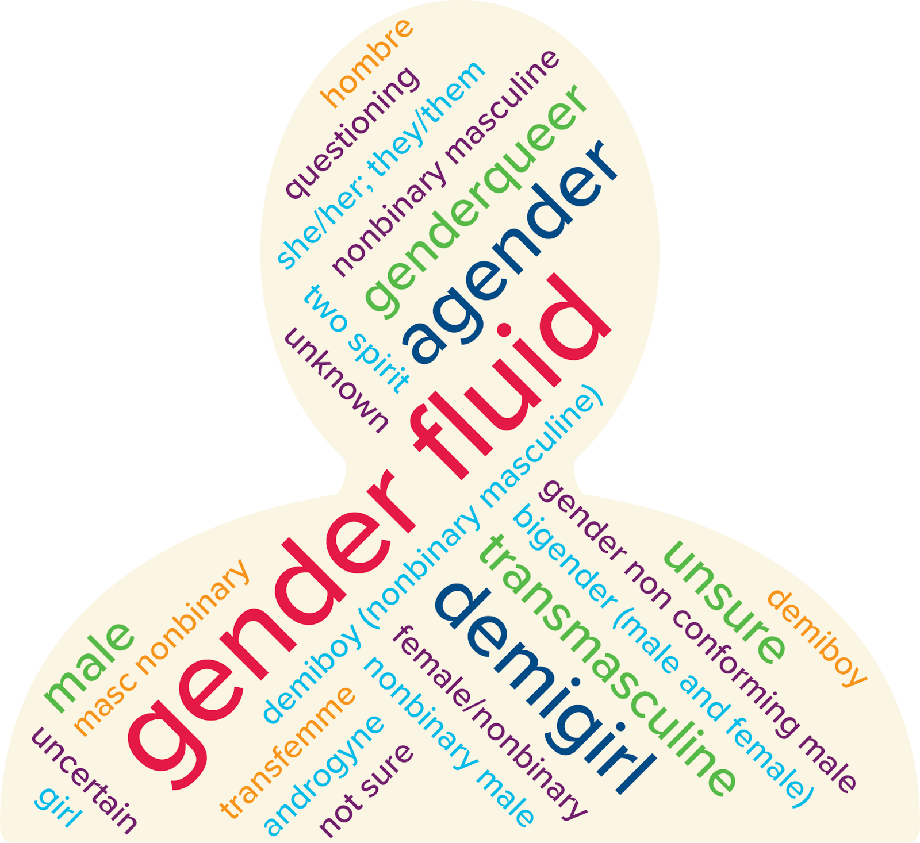
Figure 1. Gender Identity Word Visualization

Note. The size of the terms displayed are proportional to the frequency of their use.

Figure 2. Sexual Orientation Word Visualization
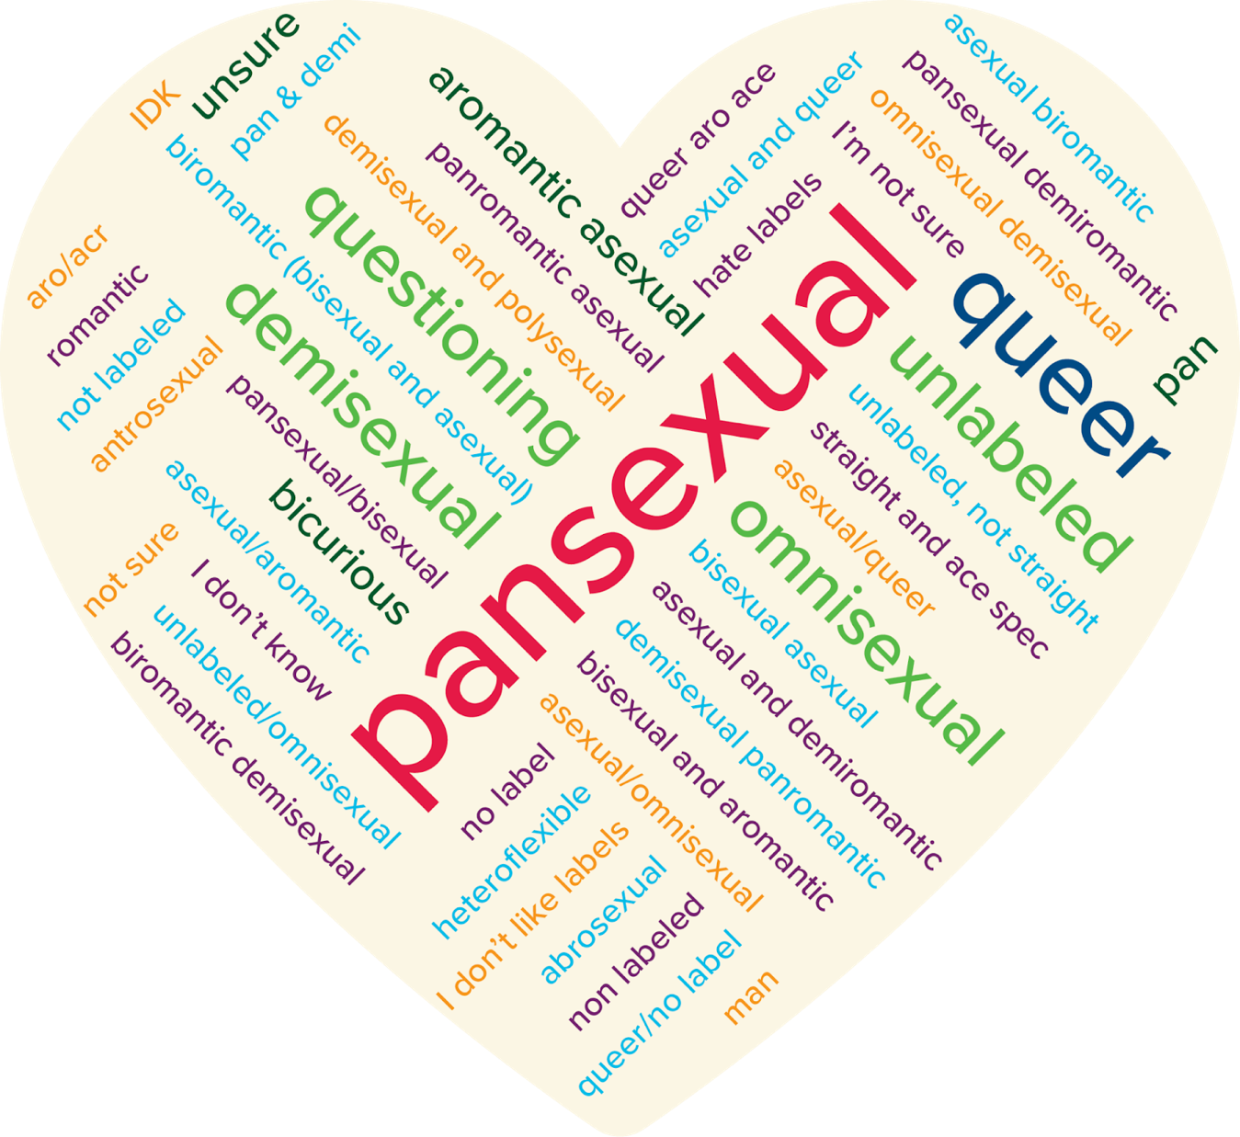
Note. The size of the terms displayed are proportional to the frequency of their use.

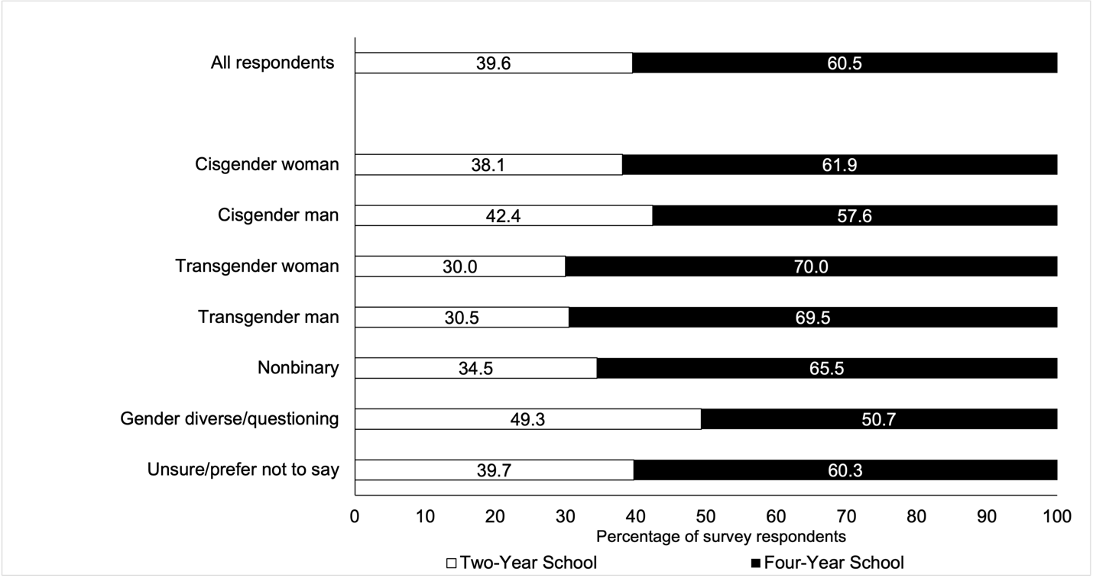
Figure 3. Plans for college enrollment
Note. Rates depicted in the figure represent 7,522 survey respondents who indicated plans to attend college. Of the full survey sample of high school seniors (n = 10,221), 9,230 respondents indicated that they planned to go to college, 170 said they did not plan to attend college, 294 expressed that they were unsure, and 527 did not respond to the question.

Figure 4. Plans for degree completion 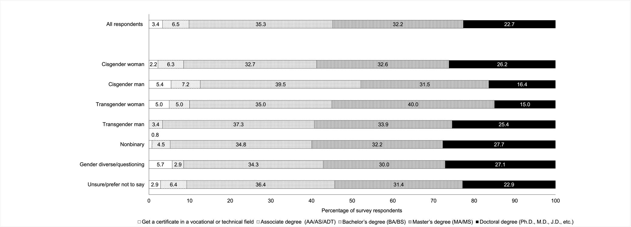
Note. Rates depicted in the figure represent 7,497 survey respondents who indicated plans for degree completion.

Figure 5. Regression of Overall High School Experience on Gender Identity Categories

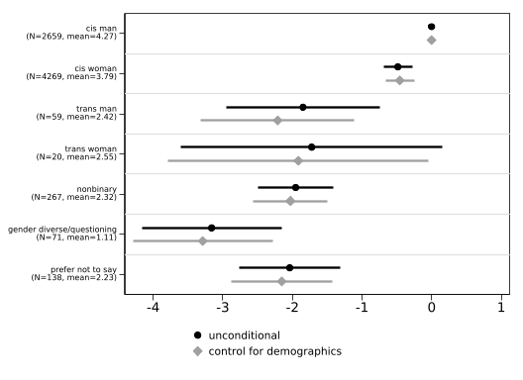
Note. For the unconditional model, n = 7,483. For the model controlling for demographics (race/ethnicity and parental level of education), n = 7,464. The lines indicate 95 percent confidence intervals while the sample frequency and mean index of each gender identity are reported in parentheses.

Figure 6. Regression of General College Worries on Gender Identity Categories

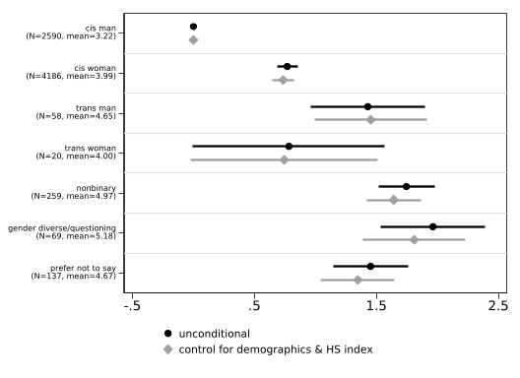
Note. We estimate regression models with gender indicators for an unconditional model (n = 7,319) and include race/ethnicity indicators, parental education indicators, and a constructed high school experience index as covariates for the specification with control variables (n = 7,276). The lines indicate 95 percent confidence intervals while the sample frequency and mean for each gender identity are reported in parentheses.

Figure 7. Regression of Worries about Discrimination on Gender Identity Categories

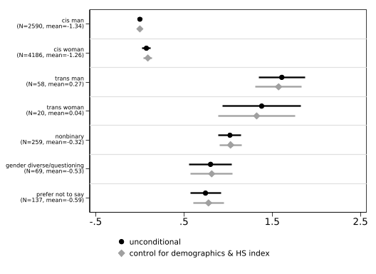
Note. We estimate regression models with gender indicators for an unconditional model (n = 7,319) and include race/ethnicity indicators, parental education indicators, and a constructed high school experience index as covariates for the specification with control variables (n = 7,276). The lines indicate 95 percent confidence intervals while the sample frequency and mean for each gender identity are reported in parentheses.

Figure 8. Regression of Worries about Financial Burdens on Gender Identity Categories

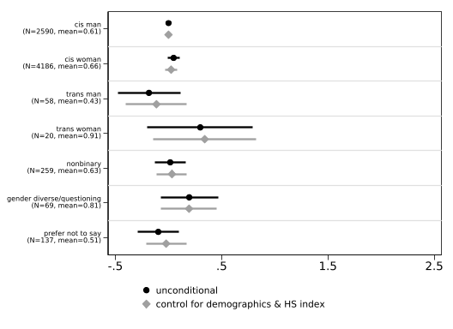
Note. We estimate regression models with gender indicators for an unconditional model (n = 7,319) and include race/ethnicity indicators, parental education indicators, and a constructed high school experience index as covariates for the specification with control variables (n = 7,276). The lines indicate 95 percent confidence intervals while the sample frequency and mean for each gender identity are reported in parentheses.

Appendix

Table A1. Two-Way Tabulation by Gender Identity and Sexual Orientation (n = 7,462)
Gender identity: | Sexual orientation categories
 | Straight/heterosexual | Gay or lesbian | Bisexual/pansexual/omnisexual | Asexual/aromantic/demisexual | Other/queer/  questioning | Prefer not to say | Total
Cisgender man | 85.03 | 4.03 | 5.09 | 0.75 | 0.57 | 4.52 | 100.00
Cisgender woman | 68.05 | 3.03 | 17.85 | 2.25 | 1.50 | 7.32 | 100.00
Transgender man | 6.90 | 32.76 | 32.76 | 6.90 | 12.07 | 8.62 | 100.00
Transgender woman | 20.00 | 40.00 | 25.00 | 10.00 | 0.00 | 5.00 | 100.00
Nonbinary | 1.92 | 18.77 | 50.19 | 13.41 | 9.58 | 6.13 | 100.00
Gender diverse/questioning | 2.90 | 13.04 | 50.72 | 14.49 | 18.84 | 0.00 | 100.00
Prefer not to say | 7.91 | 6.47 | 33.09 | 10.07 | 4.32 | 38.13 | 100.00
Total | 69.45 | 4.42 | 15.17 | 2.43 | 1.74 | 6.79 | 100.00
Note. Each cell represents the percentage of students within each gender category that indicated the corresponding sexual orientation.

Table A2. High School Experience Items and Construct

 | N | Mean
Items:
How do you rate your high school academic experience | 7,847 | .65
How do you rate your high school social experience | 7,825 | .115
I belong in my high school community | 7,711 | .573
Teachers and staff at my high school care about my future | 7,711 | 1.098
I received good advising from high school about college | 7,713 | .728
I feel prepared for college | 7,709 | .66
Construct:
General high school experience | 7,687 | 3.829
Note. The first six rows include the Likert-scale survey items that relate to a student’s high school experience. All items range from -2 to 2, with -2 indicating a very negative experience, 2 indicating a very positive experience, and 0 indicating a neutral experience. The final row summarizes the general high school experience construct, ranging from -12 to 12, which includes all six aforementioned high school experience items. The construct is only created for students who reported non-missing values for all six high school experience items.

* This research was supported by the College Futures Foundation and conducted in partnership with the California Student Aid Commission. The authors are also grateful for ongoing support from the Stuart Foundation to the California Education Lab. The findings and conclusions here are those of the authors alone and do not necessarily reflect the positions or policies of the funders or of the California Student Aid Commission. The authors are also grateful to Elizabeth Friedmann, Sherrie Reed, Paco Martorell, and Scott Carrell for their expertise and support in the construction of the survey, analysis, and review of findings.
† Author order was determined alphabetically.

